**My Support Ticketing System**

**User Manual**

Contents

Chapter 1 Introduction 4

Chapter 2 Getting Started 5

2.1 Before you start 5

2.2 What is Unassigned 5

2.3 What is Pending 5

2.4 What is Knowledge Base 5

Chapter 3 Installation Guide 6

3.1 Setting up the Web Server 6

3.2 Setting up the database 8

Chapter 4 Home Page 11

4.1 Total Unassigned 11

4.2 Total Pending 12

4.3 Pending List By Agent 12

4.4 Making use of the Home page 12

Chapter 5 Ticketing Page 13

5.1 Ticketing Table 13

5.1.1 Agent dropdown box 14

5.2 New Ticket 15

5.3 Edit Ticket 16

Chapter 6 KnowledgeBase Page 17

6.1 New Article 17

6.2 Search Article 19

6.2.1 Edit Article 19

Chapter 7 Agent Page 20

7.1 Agent Table 20

7.2 New Agent 21

7.3 Change Password 22

Chapter 8 Login Page 23

# Chapter 1 Introduction

My support Ticketing System is a ticketing system that can help support agents to manage customer support request. The system current offer two module, which are Ticketing System and Knowledge Base.

**Ticketing System** allow agents to manually convert customer issue into a ticket. The agent then can assign the ticket to himself, or temporary put into the unassigned list first. The quantity of pending tickets and unassigned tickets will be used to analyze the team performance.

**Knowledge Base** is a repository that allow the agent to share their knowledge on rectify some issue by adding a new article. Other agent who encounter the same problem can refer to the article and solve the problem.

# Chapter 2 Getting Started

## 2.1 Before you start

The system use Apache web server to host this web application, and use MySQL database management system to store the data.

The system initially will have only 1 user which is ADMIN and password is also ADMIN. You might need to sign in using ADMIN first to create your own user ID before starting to use the system.

## 2.2 What is Unassigned

In this system, unassigned are refer to those tickets which are currently does not assign to anyone, which means no one is handling the case right now.

## 2.3 What is Pending

In this system, pending are refer to those tickets which are not yet complete.

## 2.4 What is Knowledge Base

In this system, knowledge base is a repository to store the problems and it solutions. It allow agents to share their knowledge to the other agents. Each problem and its solutions are called article.

# Chapter 3 Installation Guide

## 3.1 Setting up the Web Server

1. Download XAMPP at [https://www.apachefriends.org](https://www.apachefriends.org/)
2. Right click the XAMPP installer and go to properties, go to general tab and tick unblock the file (you can skip this step if there is no tick box to unblock)
3. Double click the XAMPP installer to install XAMPP
4. You might see below waning during the installation.

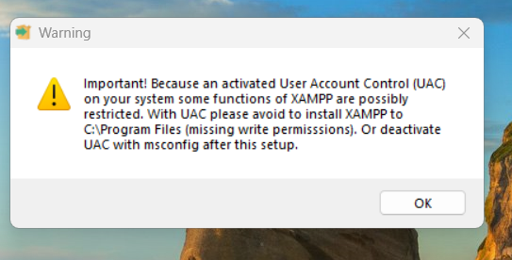

There are 2 ways to rectify this issue:

1. Go to Control Panel\User Accounts\User Accounts, and click Change User Account Control Settings, move the slider down to Never notify, then restart the PC
2. Simply click OK and proceed to next step until it ask you select a folder to install, change the file path to C:\xampp
3. Continue the installation until it ask you to select components, make sure all has been ticked

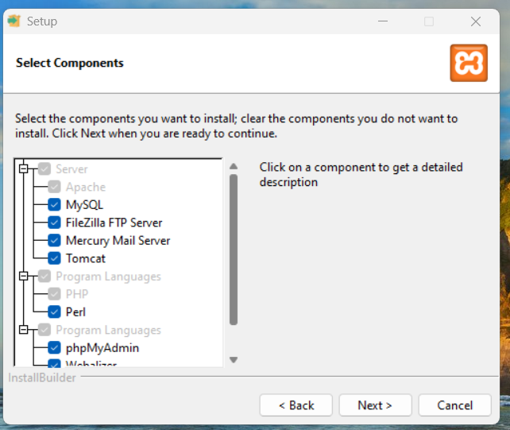

1. Click Next and it will ask you the folder to install, make sure the file path is C:\xampp

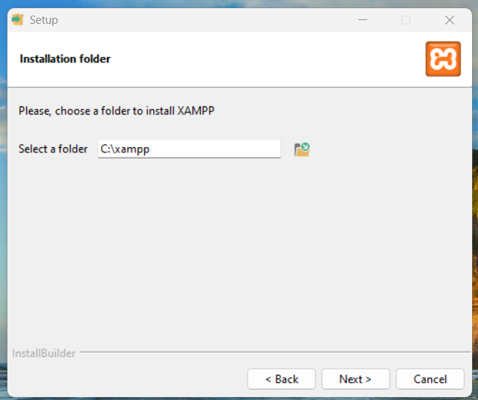

1. Click Next, then continue and wait for the installation, then click Finish.
2. Open the XAMPP Control Panel, you can simply type from your search box or go to C:\xampp and double click the xampp-control.exe
3. Click start for the Apache and MySQL

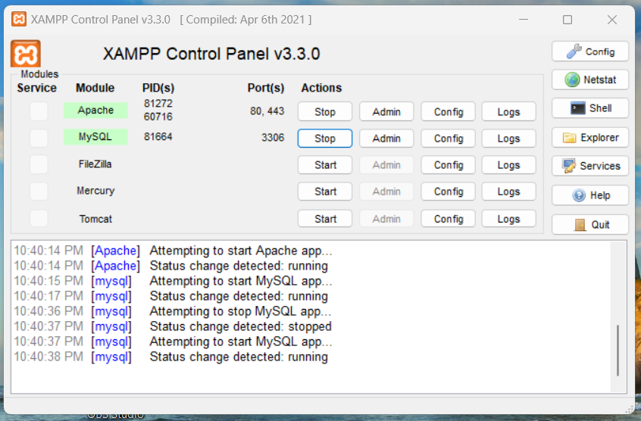

1. Put the entire MySupportTicketingSystem folder into C:\xampp\htdocs

## 3.2 Setting up the database

1. From the XAMPP Control Panel, click Config from the Apache, and click phpMyAdmin (config.inc.php)

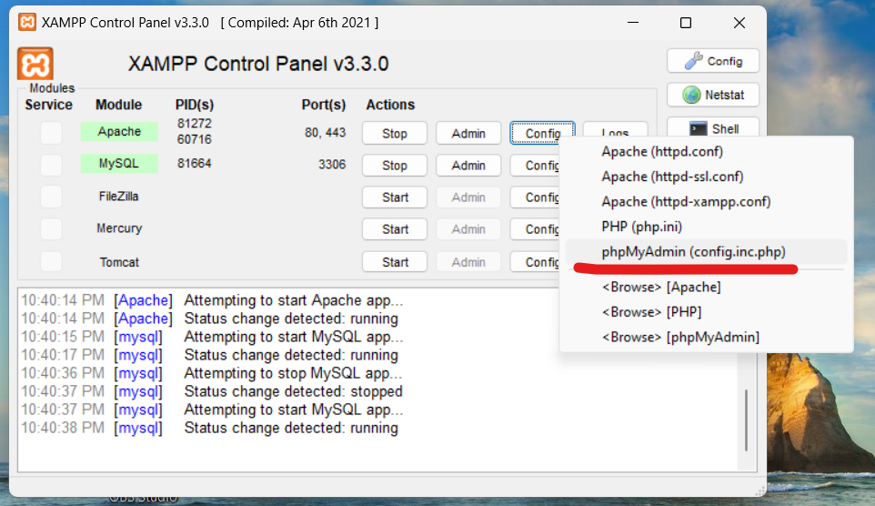

1. In the config.inc.php, change the **“$cfg['Servers'][$i]['auth_type'] = 'config';”** to **“$cfg['Servers'][$i]['auth_type'] = 'cookie';”** and save the file. This setting indicates that phpMyAdmin will use cookie-based authentication for accessing the MySQL server, so it will be convenient to use.
2. (optional) This step is optional, you can click the Shell button from the XAMPP control panel and execute this command: **“mysqladmin.exe -u root password root”**, you can replace the root behind the password to the password you want to set. The password is use for sign in the database.
3. Open your web browser and go to <http://localhost/phpmyadmin/>, then sign in using root without password (or the password which you have set in previous step).
4. Go to C:\xampp\htdocs\MySupportTicketingSystem\Tools and open the SQL Query.txt and copy all the query. Then from phpMyAdmin, click SQL, paste the query and click Go.

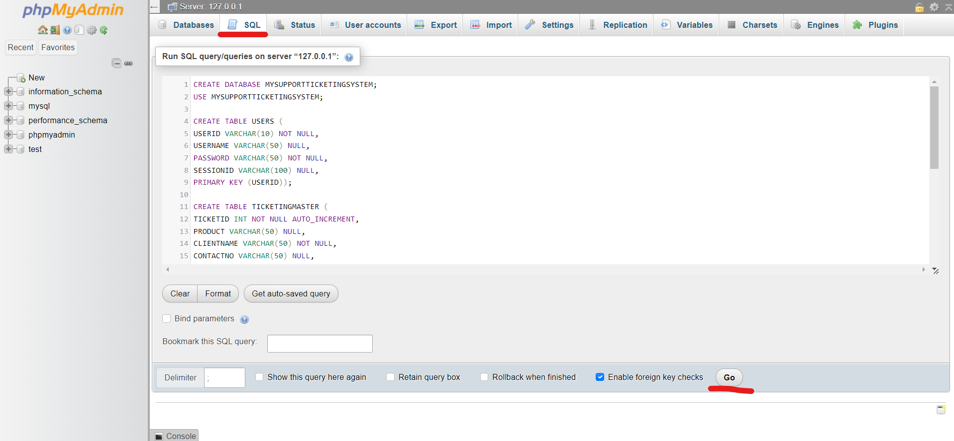

1. Then, go to C:\xampp\htdocs\MySupportTicketingSystem, and edit the Credential.php using notepad. You will see **“$mysqli = new mysqli("localhost", "root", "password", "MYSUPPORTTICKETINGSYSTEM");”**, change the “password” to “” (or change to “*the password you have set before*”)
2. After that, go to your web browser and go to <http://localhost/MySupportTicketingSystem/Login.php>, then you can sign in using ADMIN ID and password is also ADMIN to create additional user. Then you can start using the system.

# Chapter 4 Home Page

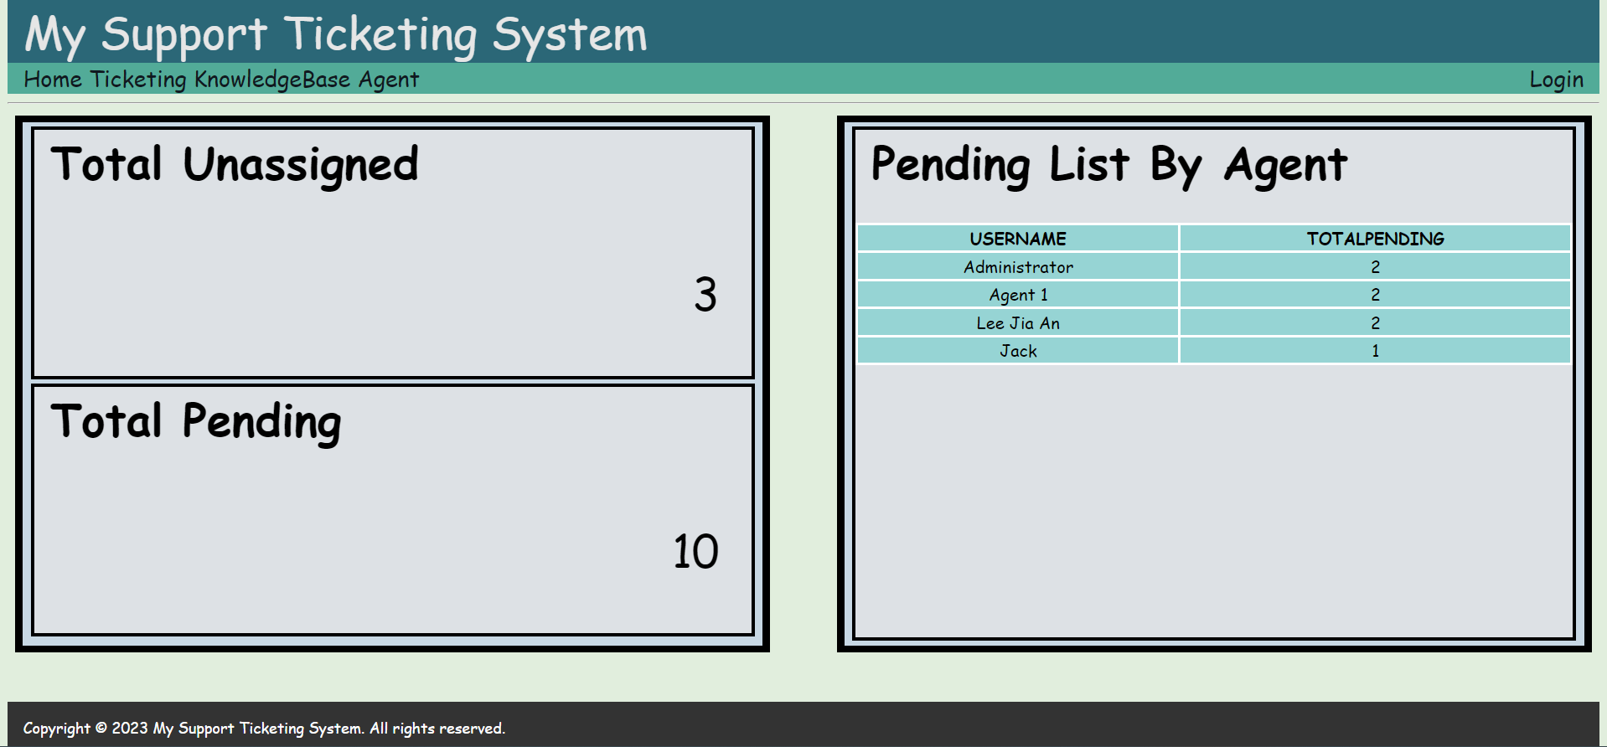

**Figure 4.1 Home Page**

Starting from the left of the navigation panel, the first page you can access is the Home page. In home page, you can find the total number of unassigned tickets, the total number of pending tickets, and a list of agent with their total number of pending tickets.

## 4.1 Total Unassigned

Total unassigned will show the total number of unassigned tickets. For example based on Figure 4.1 above, there are total 3 unassigned tickets. The system calculate the total number of unassigned tickets by checking those tickets which the agent field are currently set to “UNASSIGNED” and are not completed. This value will be refresh for every 10 second to get the real-time data for total number of unassigned tickets.

## 4.2 Total Pending

Total Pending will show the total number of pending tickets which are waiting for someone to handle and solved it. For example based on Figure 4.1 above, there are total 10 pending tickets. The system calculate the total number of pending tickets by checking those tickets which are not completed. Therefore, it will also include the total number of unassigned tickets. This value will be refresh for every 10 second to get the real-time data for total number of pending tickets.

## 4.3 Pending List By Agent

Pending list by agent will show a table with a list of agent and their total number of pending tickets. The sum total of the pending tickets in the table combine with the total number of unassigned tickets will be equal to the total number of pending tickets. This table will be refresh for every 10 second to get the real-time data for the pending list by agent.

## 4.4 Making use of the Home page

The team leader, manager, or boss can monitor the total of pending or unassigned tickets, and the performance of the agents by using this page. Besides that, user does not require to sign in to access the home page. Therefore the home page can be accessed by anyone. Auto refreshing the values and table every 10 second allow user no need to keep refresh the page manual to get the real-time data. Therefore, it is suggested that this Home page can be opened in a bigger screen like television for monitor.

# Chapter 5 Ticketing Page

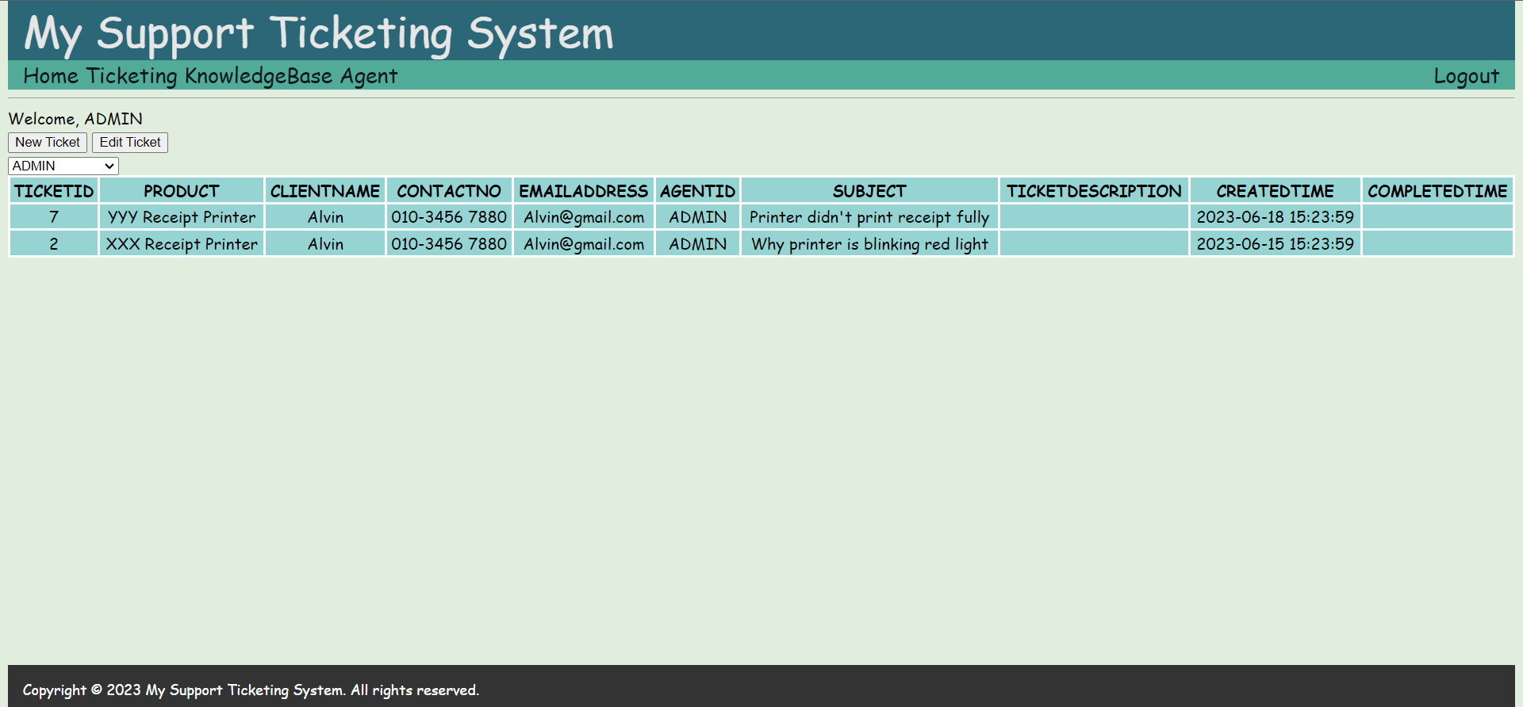

**Figure 5.1 Ticketing Page**

Next to the Home page is the Ticketing page, which is the second page from the system. Starting from this page, you are required to signing in to the system or else you will be redirect to the login page. In Ticketing page, you can find a welcoming message, then follow by two buttons which are New Ticket and Edit Ticket, a dropdown box with Agents, and a Ticketing table.

## 5.1 Ticketing Table

Ticketing table will show a list of tickets which has been entered into the system. The tickets list is sorting by the created time in descending order so the latest ticket always on top. You can click any data rows of the table so it will be selected, and the background of the row will be change to yellow once it has been selected.

This table will show maximum of 10 tickets per page. If they are more than 10 tickets, the ‘Previous’ and ‘Next’ button will show out.

**Previous** –will show the previous 10 tickets in the table.

**Next** – will show the next 10 tickets in the table.

### 5.1.1 Agent dropdown box

At the top left side of the table, there is a dropdown box with a list of agent selections. By default it will always show as the current login user, but you can also change to another agent. Once changed, the ticketing table will be refresh and show the pending tickets of the agent which you have selected. Besides the agents, the dropdown box will also include “SHOW ALL” and “UNASSIGNED” in the selection.

**SHOW ALL** –will show all tickets, including those completed tickets.

**UNASSIGNED** – will show the tickets which are currently unassigned.

## 5.2 New Ticket

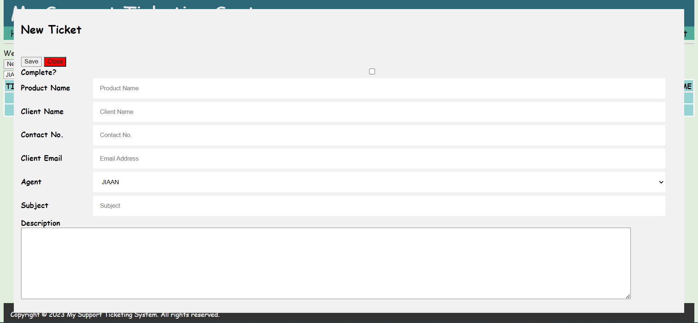

**Figure 5.2 Ticketing Form**

When you click the New Ticket button, a pop up form will appear. You can fill up this pop up form and save into the system.

**Save** – save and submit the form to the system

**Close** – close the form without update anything

**Complete ?** – tick to mark as complete, current date and time will be update as completed time to the ticket

**Product Name** – the product or software which your customer has encounter a problem, the maximum character is 50

**Client Name** – your customer name which has report the issue, it is a required field and the maximum character is 50

**Contact No.** – your customer phone no, the maximum character is 50

**Client Email** – your customer email, the maximum character is 50

**Agent** – the agent who handle the problem, it will always show as the current login agent by default, click the dropdown box to select agents to assign the ticket to other agents, or select UNASSIGNED

**Subject** – the title of this ticket, you can write the problem encountered by your customer in short, the maximum character is 100 character

**Description** – the details of the problem, the process of handling the problem, and the solution, there are no character limit in this field

Each new ticket created will be auto assigned with a ticket ID to make each ticket unique, and each ticket will also have the created date and time, and all of this above field will be show in the ticketing table.

## 5.3 Edit Ticket

You will need to select any data row from the ticketing table and click the Edit Ticket button to edit the ticket. Once click the Edit Ticket button, the ticketing form will pop up, with the information of the selected ticket. From here you can modify the content of the ticket or update the ticket with new information.

# Chapter 6 KnowledgeBase Page

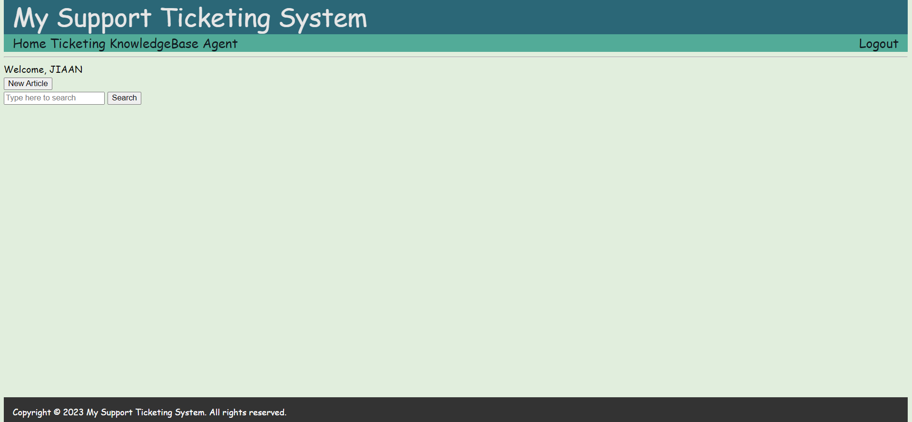

**Figure 6.1 KnowledgeBase Page**

Next to the Ticketing page is the KnowledgeBase page, which is the third page from the system. KnowledgeBase allow you to create, search, and edit article, an article will contain the information of the problem and the solution to handle the problem. In KnowledgeBase page, you can find a welcoming message, then follow by a New Article button, then a search box with a search button.

## 6.1 New Article

You can click the New Article button to create an article into the system. By clicking the New Article button, an Article form will be pop up.

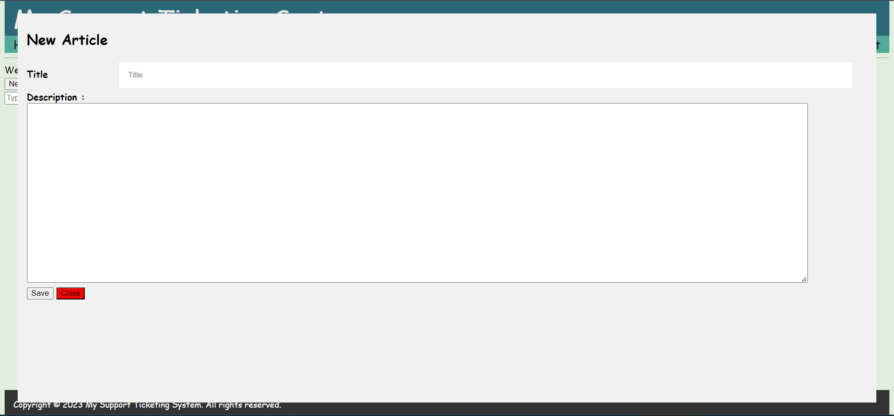

**Figure 6.2 Article Form**

**Title** – enter a title of this article, you can also enter the problem in short, this is the required field and the maximum character is 50

**Description** – the details of the problem and the solution of the problem, there are no character limit in this field

**Save** – save and submit the form to the system

**Close** – close the form without update anything

## 6.2 Search Article

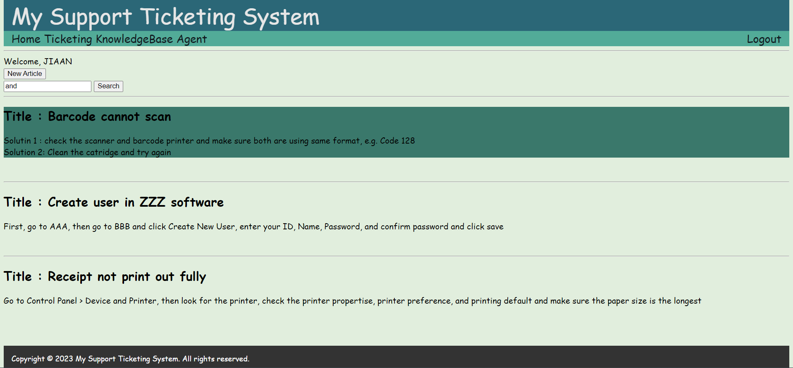

**Figure 6.3 Search Article**

By enter a keyword in the search box and click the Search button, a list of article will be display out which either the title or the details description has match with the keyword. You can find the problem and its solution from the list.

### 6.2.1 Edit Article

Hover you mouse to the article will change the background to dark green color. You can click the article if you want to edit it. When you click the article, an article form will pop up, with the information of the clicked article. From here you can modify the content of the article or update the article with new information.

# Chapter 7 Agent Page

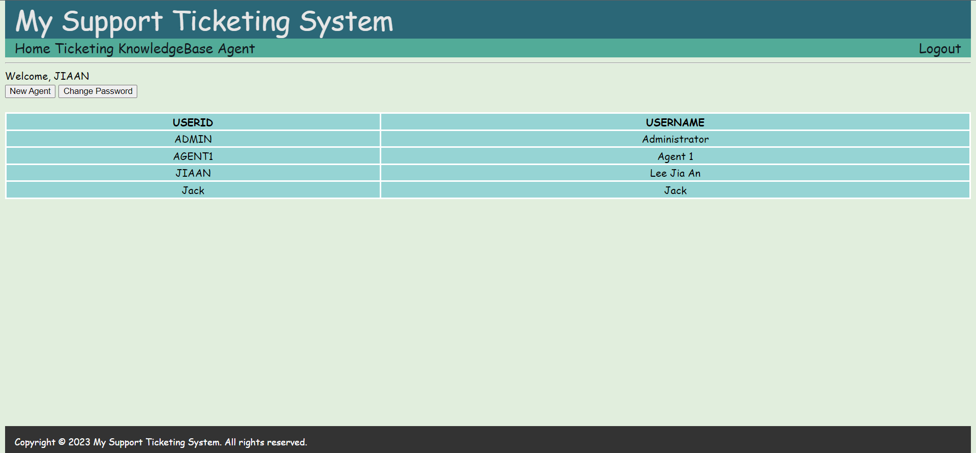

**Figure 7.1 Agent Page**

Next to the KnowledgeBase page is the Agent page, which is the forth page from the system. Agent page allow you to create new user, which is also agent, into the system. In Agent page, you can find a welcoming message, then follow by two buttons which are New Agent and Change Password, and Agent table.

## 7.1 Agent Table

Agent table will show a list of agent which has been created into the system. You can click any rows of the table so it will be selected, and the background of the row will be changed to yellow once it has been selected. This table will show maximum of 10 agents per page. If they are more than 10 agents, the ‘Previous’ and ‘Next’ button will show out.

**Previous** –will show the previous 10 agents in the table.

**Next** – will show the next 10 agents in the table.

## 7.2 New Agent

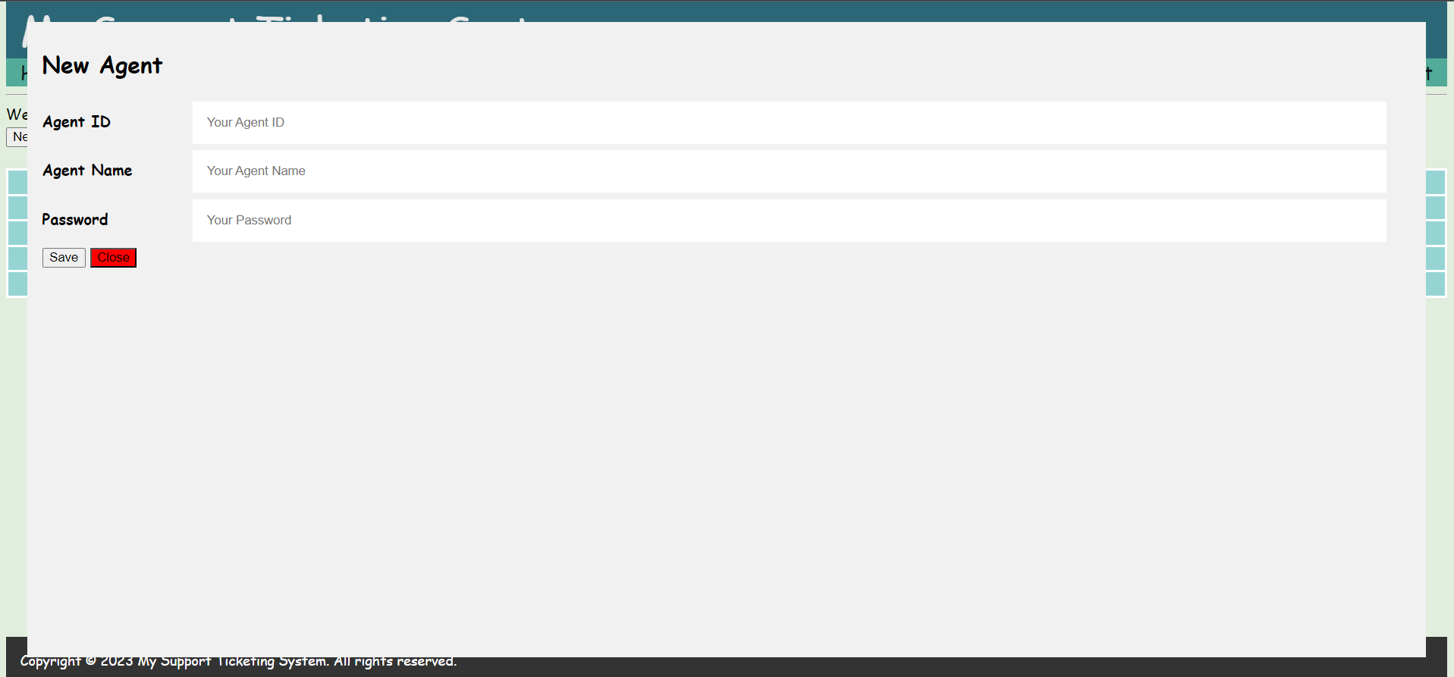

**Figure 7.2 New Agent Form**

Initially there will be only 1 user ID inside the system which is ADMIN and its password is also ADMIN. You can click the New Agent button to create additional agent. Once you click the New Agent button, a New Agent Form will pop up.

**Agent ID** – the ID that will be used to sign in the system

**Agent Name** – the name of the Agent, will show in welcome message and the pending list table

**Password** – the password that will be used to sign in to the system

**Save** – save and submit the form to the system

**Close** – close the form without update anything

## 7.3 Change Password

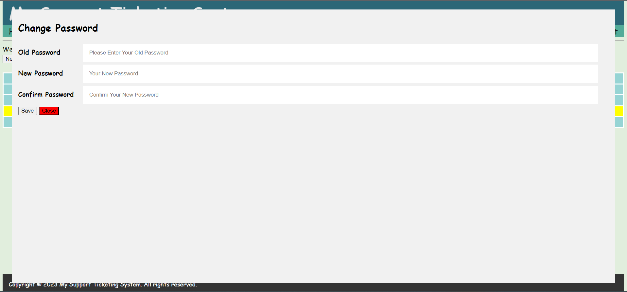

**Figure 7.3 Change Password Form**

In order to change password, you will need to select the agent from the agent table first and click the Change Password button. Once the Change Password button has been clicked, the Change Password form will pop up. In order to change password successfully, system will check the old password entered is same with current password, and the new and confirm password are same.

**Old Password** – the agent old password which is also current password

**New Password** – the new password that will be used to login in future

**Confirm Password** – confirm password must same with the new password

**Save** – save and submit the form to the system

**Close** – close the form without update anything

# Chapter 8 Login Page

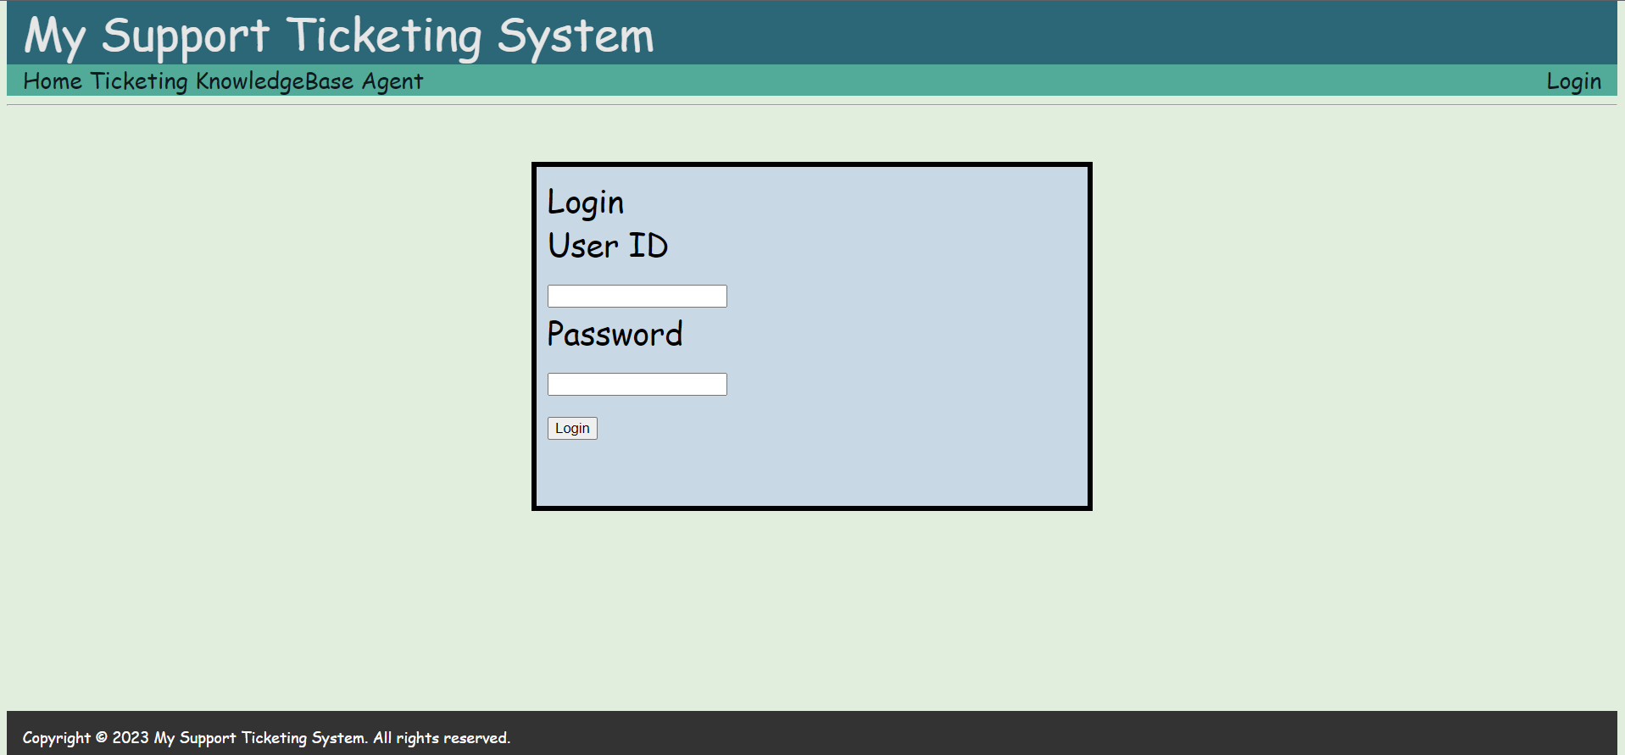

**Figure 8.1 Login Page**

The last button from the navigation panel is the Login / Logout button which when clicked, will be redirect to the Login page. Without sign in to the system, you can only access the Home page and Login page. Accessing to the other page will redirect back to the Login page.

In Login page, you can find a box with a Login form. You are required to enter your user ID and Password and click the login button in order to sign in to the system, and the ID and password must already exist in the system.

The Login button from the navigation panel will change to Logout button once you have sign in to the system, and it will change back to Login button once you have clicked the Logout button, and you will be redirect back to the Login Page.